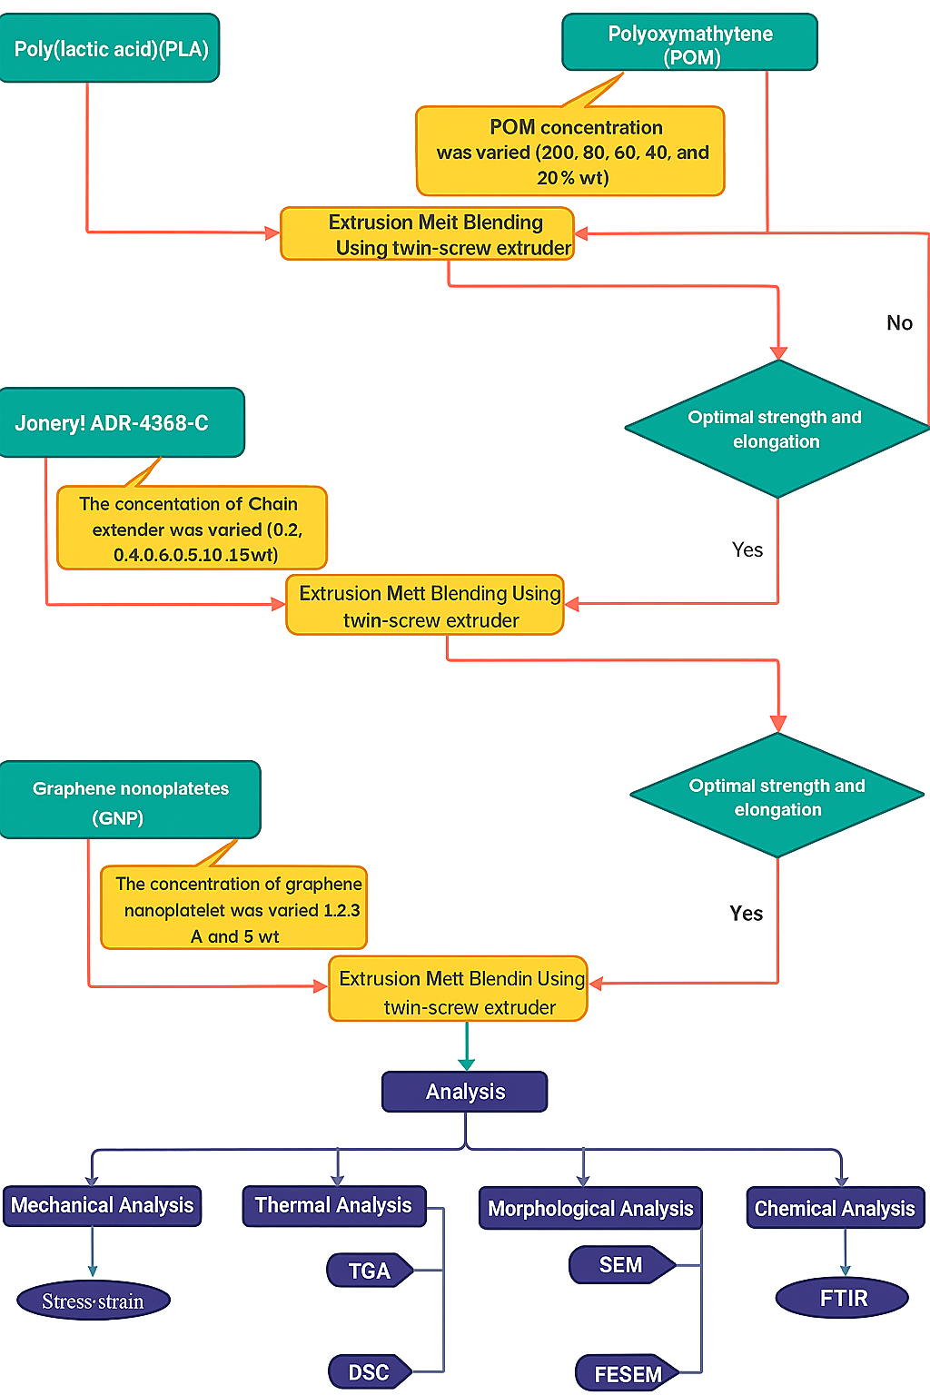

**Experimental workflow diagram**

**Table:** Compositions of the prepared samples

|  |  |  |  |  |
| --- | --- | --- | --- | --- |
| Formulations | PLA | POM | ADR | GNP |
| (wt.%) | | | |
| PLA/POM (0/100) | 0 | 100 | 0 | 0 |
| PLA/POM (20/80) | 20 | 80 | 0 | 0 |
| PLA/POM (40/60) | 40 | 60 | 0 | 0 |
| PLA/POM (60/40) | 60 | 40 | 0 | 0 |
| PLA/POM (80/20) | 80 | 20 | 0 | 0 |
| PLA/POM/ADR 40/60/0.2 | 40 | 60 | 0.2 | 0 |
| PLA/POM/ADR 40/60/0.4 | 40 | 60 | 0.4 | 0 |
| PLA/POM/ADR 40/60/0.6 | 40 | 60 | 0.6 | 0 |
| PLA/POM/ADR 40/60/0.8 | 40 | 60 | 0.8 | 0 |
| PLA/POM/ADR 40/60/1.0 | 40 | 60 | 1.0 | 0 |
| PLA/POM/ADR 40/60/1.2 | 40 | 60 | 1.2 | 0 |
| GNP1 | 40 | 60 | 0.4 | 1 |
| GNP2 | 40 | 60 | 0.4 | 2 |
| GNP3 | 40 | 60 | 0.4 | 3 |
| GNP4 | 40 | 60 | 0.4 | 4 |
| GNP5 | 40 | 60 | 0.4 | 5 |

**Morphological data**

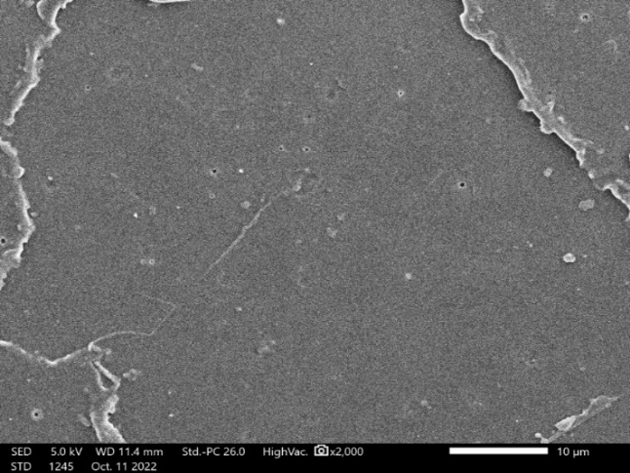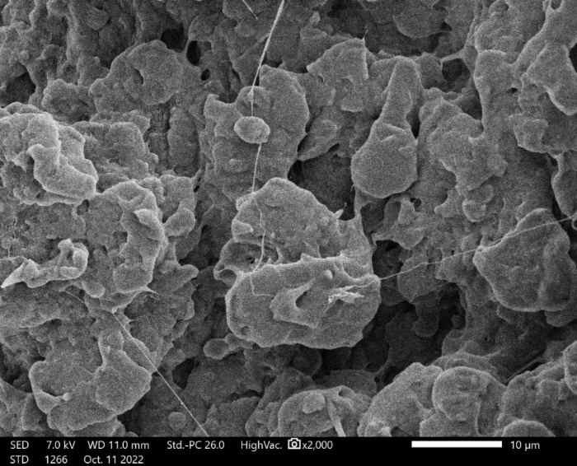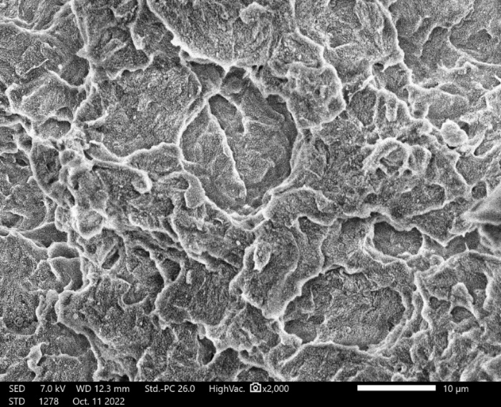

**(d)**

**ADR 0.4**

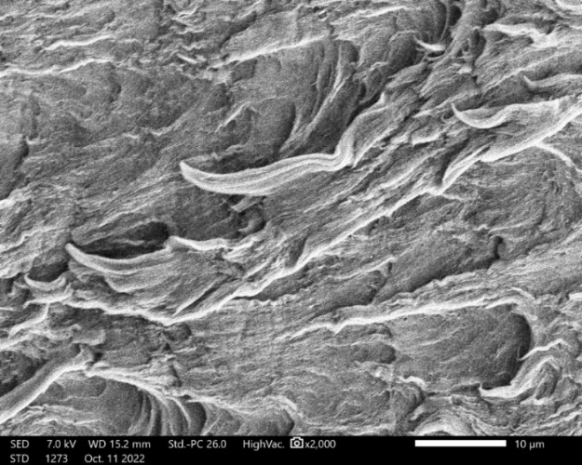

**(c)**

**ADR 0.2**

**PLA**

**(a)**

**PLA40/POM60**

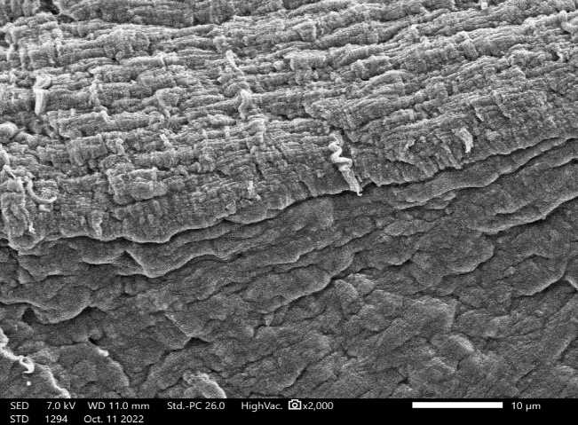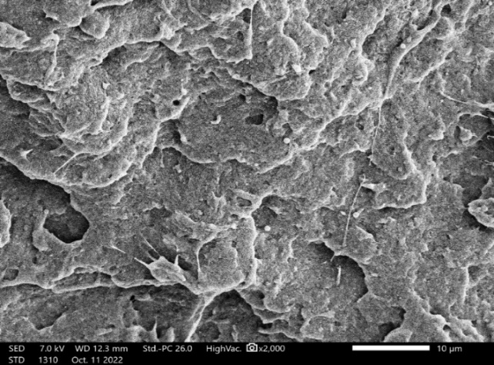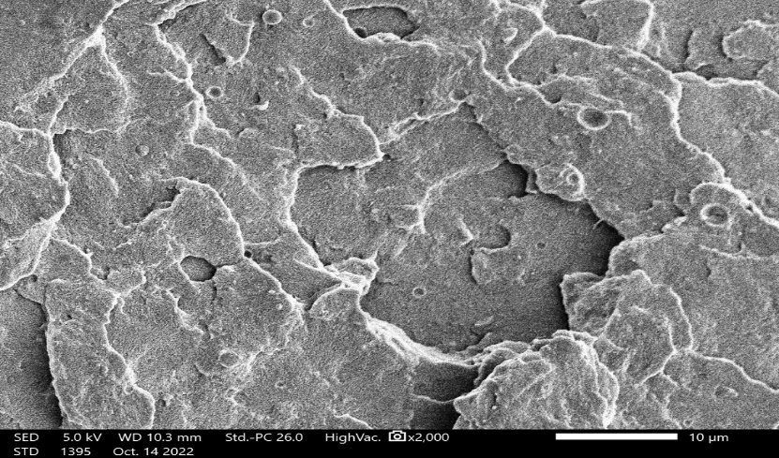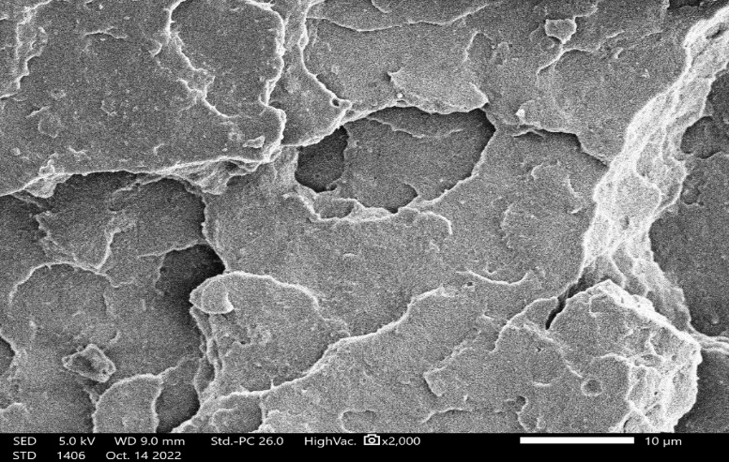

**ADR 0.6**

**A DR 0.8**

**ADR 1.0**

**ADR 1.2**

**(e)**

**(g)**

**(h)**

**(f)**

**(b)**

**Figure** SEM images: (a) PLA; (b) PLA40/POM60; (c) PLA40/POM60/ADR0.2; (d) PLA40/POM60/ADR0.4; (e)PLA40/POM60/ADR0.6; (f) PLA40/POM60/ADR0.8; (g) PLA40/POM60/ADR1.0, and (h) PLA40/POM60/ADR1.2

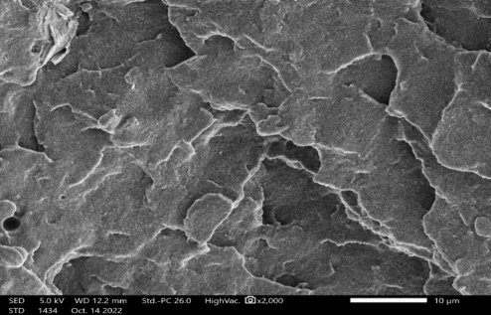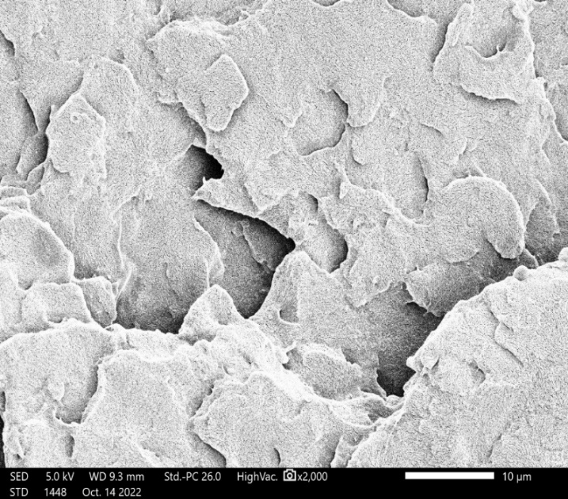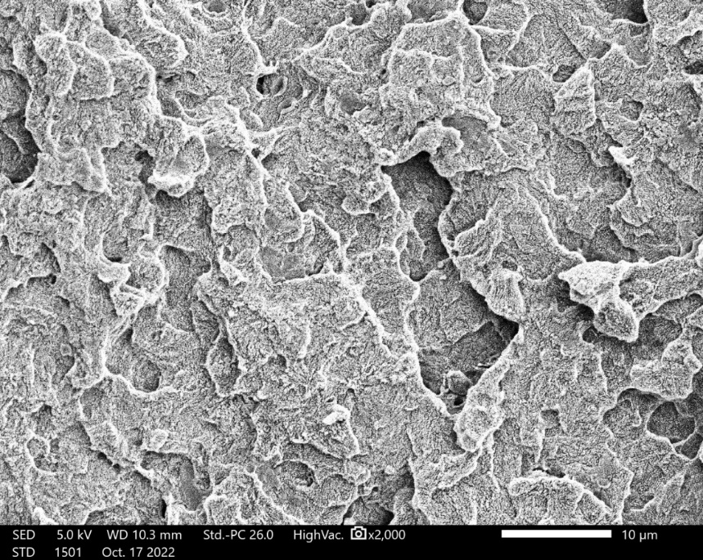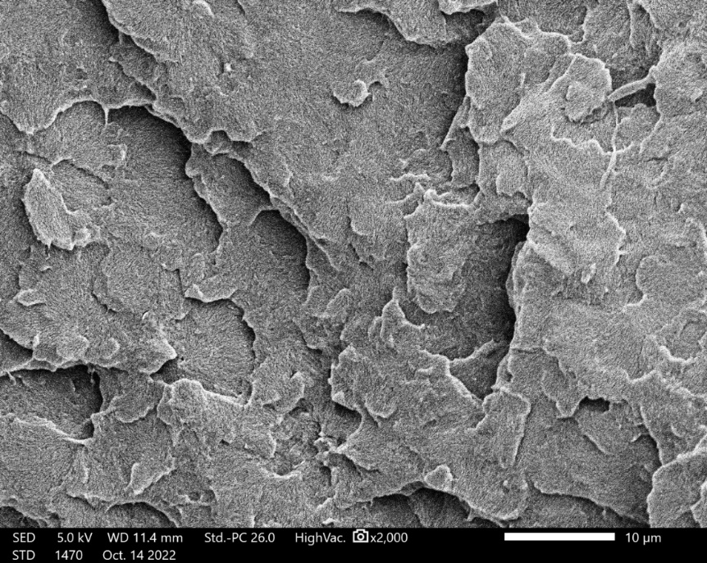

GNP1

GNP2

GNP3

GNP4

(a)

(b)

(c)

**(d)**

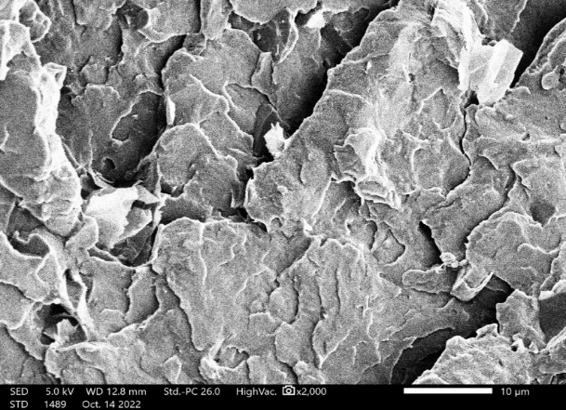

GNP5

**(e)**

(a)

(b)

**Figure** SEM at 2000x magnification of PLA40/POM60/ADR0.4/GNP: (a) GNP1; (b) GNP2; (c) GNP3; (d) GNP4; and (e) GNP5

(b)

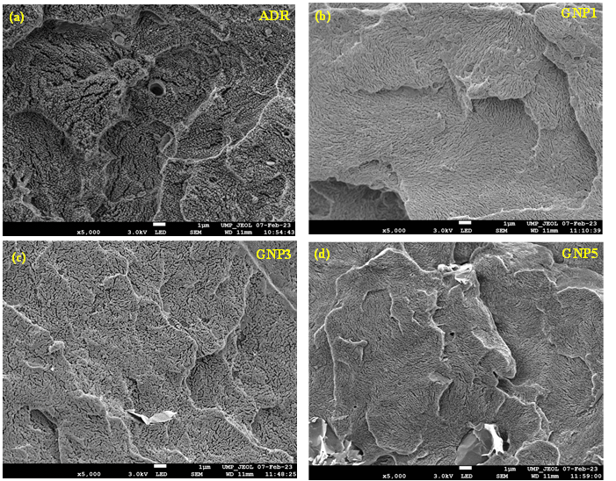

**Figure** FESEM images at a magnification of 5,000x of: (a) ADR0.4, (b) GNP1, (c) GNP3 and (d) GNP5

.

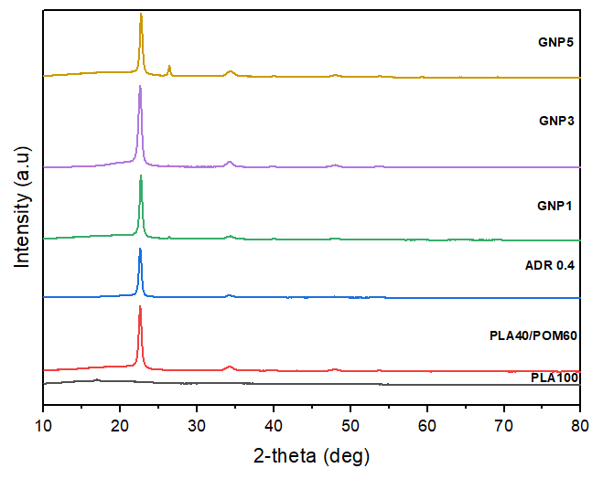

**Figure** XRD patterns of the PLA, PLA40/POM60, PLA40/POM60/ADR0.4 and PLA40/POM60/ADR0.4/GNP nanocomposites

**Mechanical data**

**Figure** Tensile strengths of pure PLA and POM

**Figure** Tensile strength for various PLA/POM blend ratios

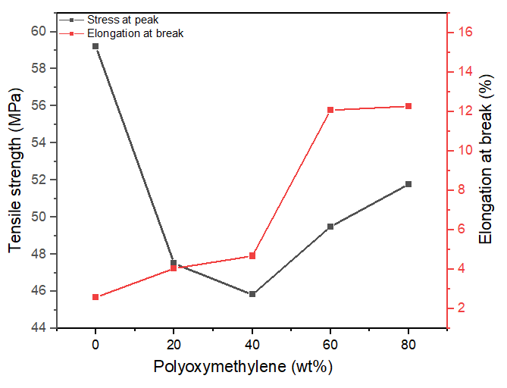

**Figure** Tensile strength and elongation at break of PLA/POM

**Figure** Young's modulus of PLA with different concentrations of POM

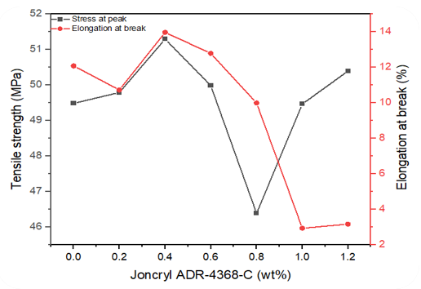

**Figure** Tensile strength and elongation at break of PLA40/POM60/ADR

**Figure** Young's modulus of PLA40/POM60 with different concentrations of ADR

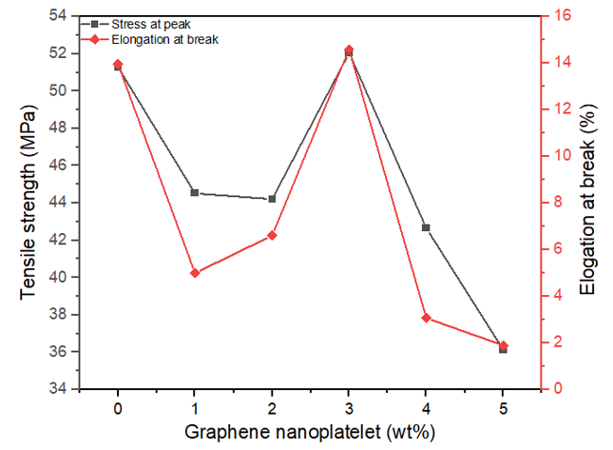

**Figure** Tensile strength and elongation at break of PLA40/POM60/ADR0.4 /GNP

**Figure** Young's modulus of PLA40/POM60/ADR with different concentrations of GNP

**Table** Stress at break, elongation at break and Young’s modulus of PLA40/POM60/ADR0.4/GNP

|  |  |  |  |  |  |  |
| --- | --- | --- | --- | --- | --- | --- |
| **GNP**  **(wt%)** | **Stress at break** | | **Elongation at break** | | **Young's Modulus** | |
| **(MPa)** | **±** | **(%)** | **±** | **GPa** | **±** |
| 0 | 51.29 | 1.78 | 13.97 | 1.80 | 18.50 | 0.246 |
| 1 | 44.52 | 1.12 | 4.99 | 0.62 | 17.42 | 0.1284 |
| 2 | 44.21 | 1.84 | 6.61 | 0.67 | 19.99 | 0.0746 |
| 3 | 52.05 | 1.91 | 14.59 | 1.08 | 22.32 | 0.1212 |
| 4 | 42.66 | 2.29 | 3.07 | 0.26 | 20.59 | 0.2179 |
| 5 | 36.13 | 0.66 | 1.90 | 0.17 | 16.58 | 0.2947 |

**Thermal data**

**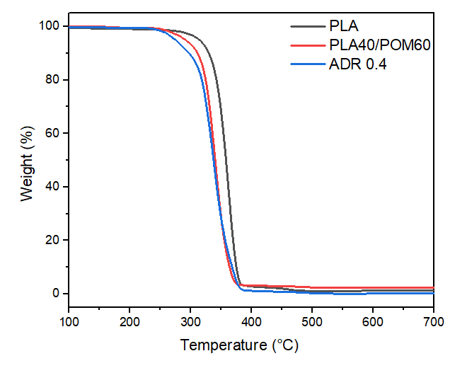****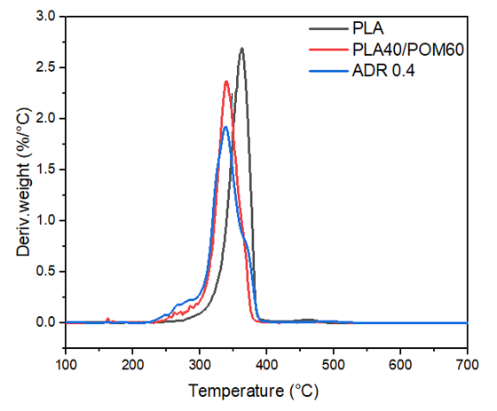**

(a) (b)

**Figure** (a)TGA and (b) DTG curves for PLA, PLA40/POM60 and the PLA40/POM60/ADR0.4 blends

**Table** T5%, T10%, T25%, and T50% for some PLA blends

|  |  |  |  |  |  |
| --- | --- | --- | --- | --- | --- |
| **Sample** | **T5%** | **T10%** | | **T25%** | **T50%** |
|  |  | |  |  |  |
| PLA | 313.81 | | 329.65 | 345.75 | 358.19 |
| PLA40/POM60 | 290.75 | | 331.02 | 327.96 | 339.89 |
| ADR0.4 | 274.84 | | 297.07 | 322.39 | 337.42 |

Table 5: Tg, Tc, Tm and Xc for the PLA, PLA40/POM60, and PLA40/POM60/ADR0.4 blends

|  |  |  |  |  |  |
| --- | --- | --- | --- | --- | --- |
| **Sample** | **Tg (°C)** | | **Tc (°C)** | **Tm (°C)** | **Xc (%)** |
| PLA | 58.32 | 92.545 | | 168.287 | 15.771 |
| PLA40/POM60 | - | - | | 163.366 | 19.275 |
| ADR0.4 | - | - | | 167.014 | 22.157 |

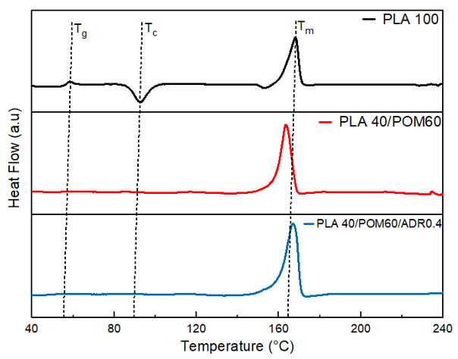

**Figure** DSC curves for PLA, PLA40/POM60, and PLA40/POM60/ADR0.4 blends

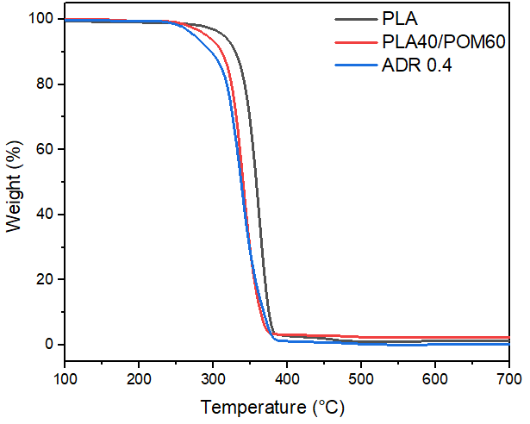 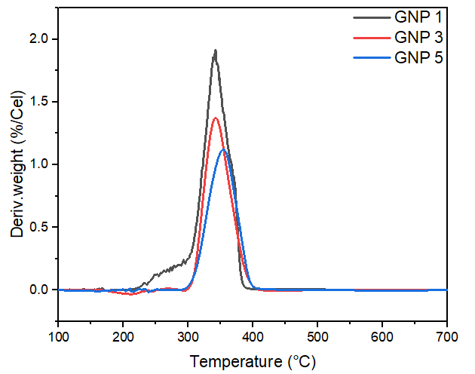

(a) (b)

**Figure** (a)TGA and (b) DTG curves for the GNP1, GNP3 and GNP5 blends

**Table** TGA characteristic temperatures

|  |  |  |  |  |  |
| --- | --- | --- | --- | --- | --- |
| **Sample** | **T5%** | **T10%** | | **T25%** | **T50%** |
| GN1 | 266.11 | | 290.67 | 318.51 | 337.48 |
| GNP3 | 255.46 | | 275.19 | 325.13 | 340.20 |
| GNP5 | 222.78 | | 237.94 | 270.51 | 335.28 |

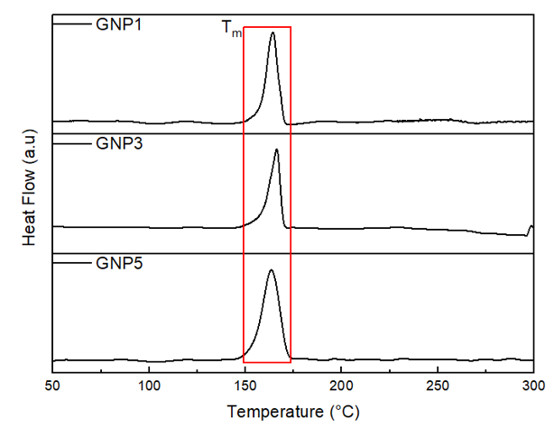

**Figure** DSC curves for PLA40/POM60/ADR0.4 with GNP1, GNP3, and GNP5

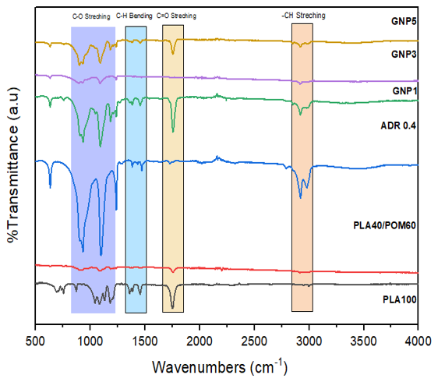

**Figure** FTIR spectra of PLA, PLA40/POM60, PLA40/POM60/ADR0.4 (ADR 0.4), PLA40/POM60/ADR0.4/GNP1 (GNP 1), PLA40/POM60/ADR0.4/GNP3 (GNP 3), and PLA40/POM60/ADR0.4/GNP5 (GNP 5)



**Figure** (a) A possible reaction mechanism and (b) a prediction of the chemical structure formed from the mixture of PLA, POM, ADR and GNP composites during melting blending